Model: T55M

Product Name: Swing door

Material: [Aluminum](C:/Program%20Files%20(x86)/Youdao/Dict/8.9.6.0/resultui/html/index.html" \l "/javascript:;) frame,glass and hardware

Size: Customized

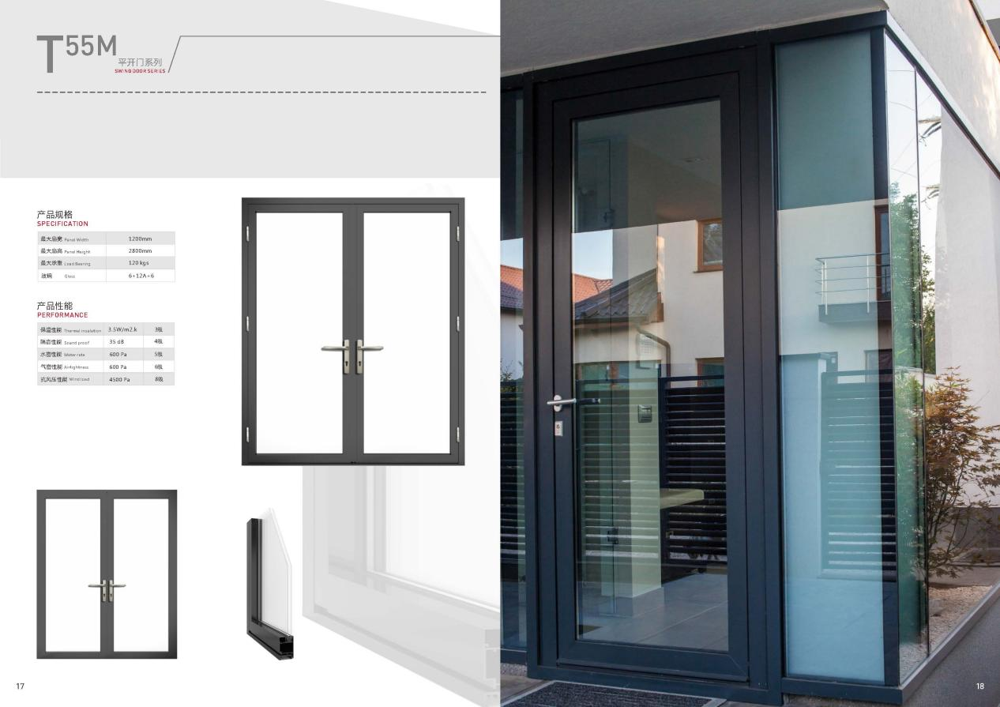

Model: T80

Product Name: Hand Window

Material: [Aluminum](C:/Program%20Files%20(x86)/Youdao/Dict/8.9.6.0/resultui/html/index.html" \l "/javascript:;) frame,glass and hardware

Size: Customized

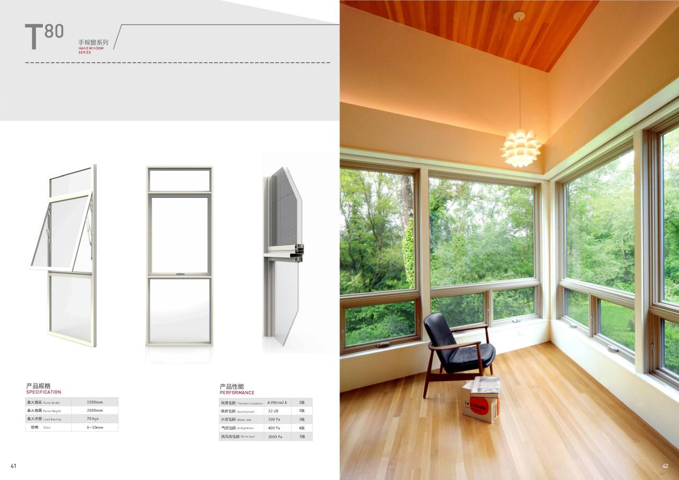

Model: T100M

Product Name: Sliding Window

Material: [Aluminum](C:/Program%20Files%20(x86)/Youdao/Dict/8.9.6.0/resultui/html/index.html" \l "/javascript:;) frame,glass and hardware

Size: Customized

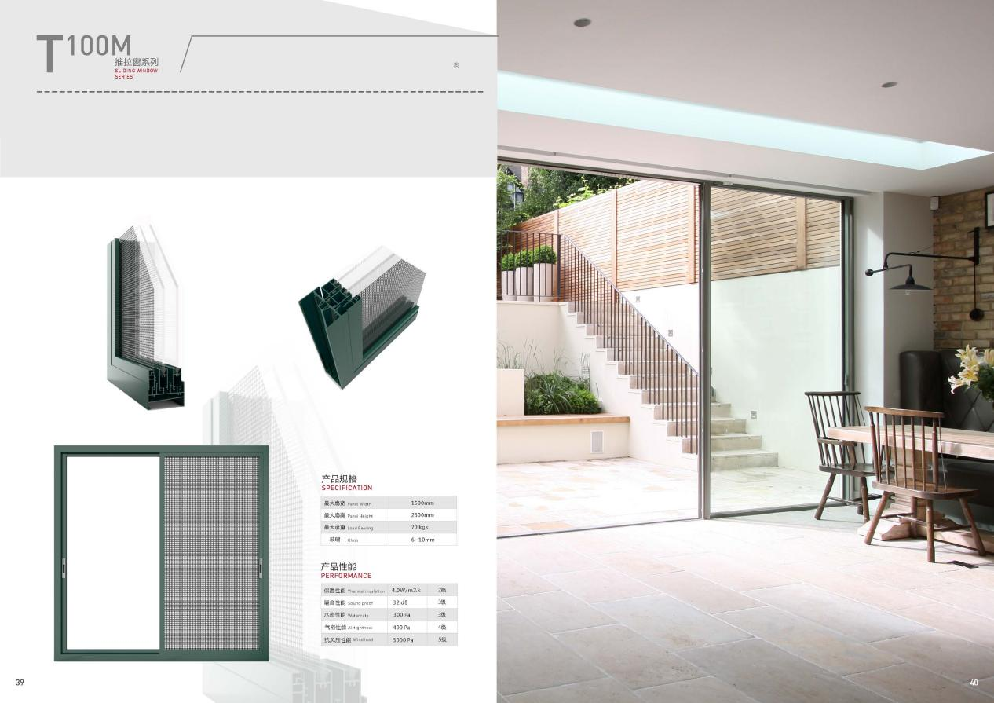

Model: T108

Product Name: Folding Door

Material: [Aluminum](C:/Program%20Files%20(x86)/Youdao/Dict/8.9.6.0/resultui/html/index.html" \l "/javascript:;) frame,glass and hardware

Size: Customized

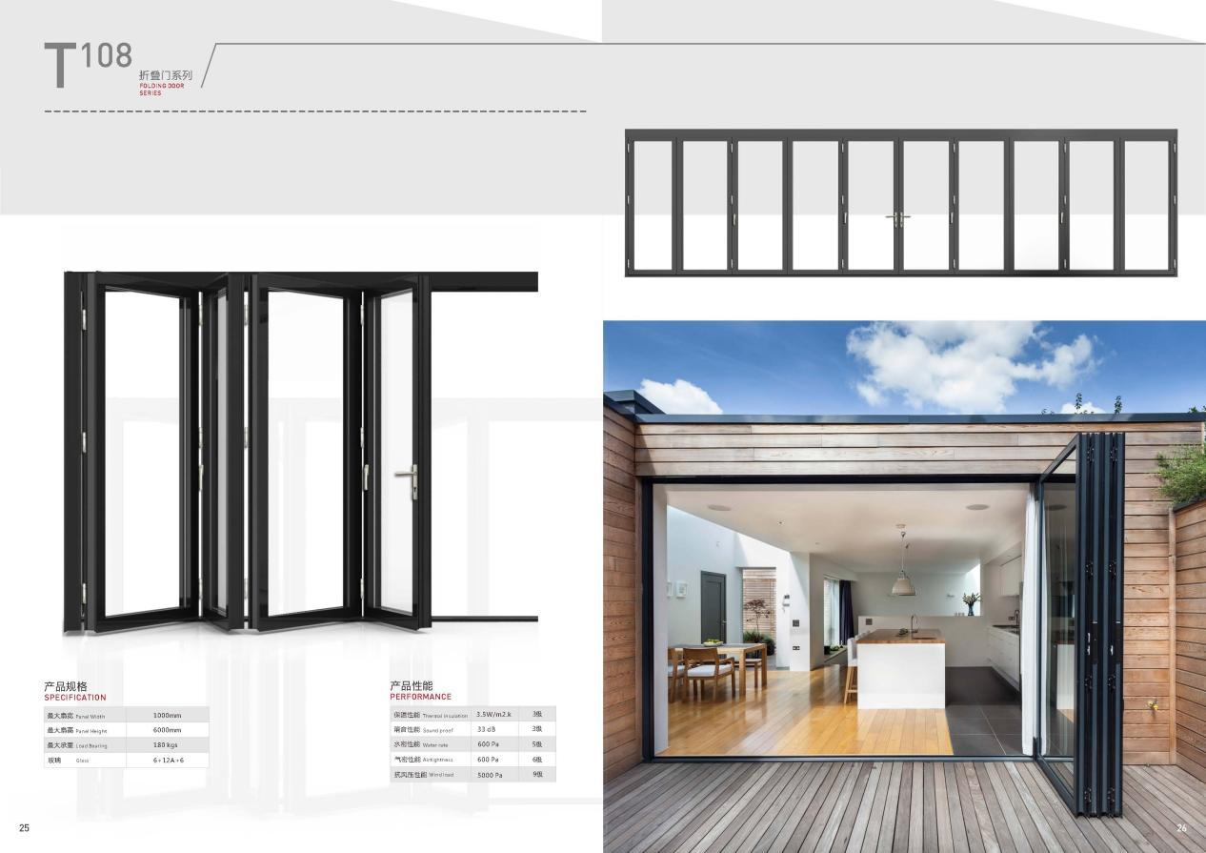

Model: T145

Product Name: Casement Window

Material: [Aluminum](C:/Program%20Files%20(x86)/Youdao/Dict/8.9.6.0/resultui/html/index.html" \l "/javascript:;) frame,glass and hardware

Size: Customized

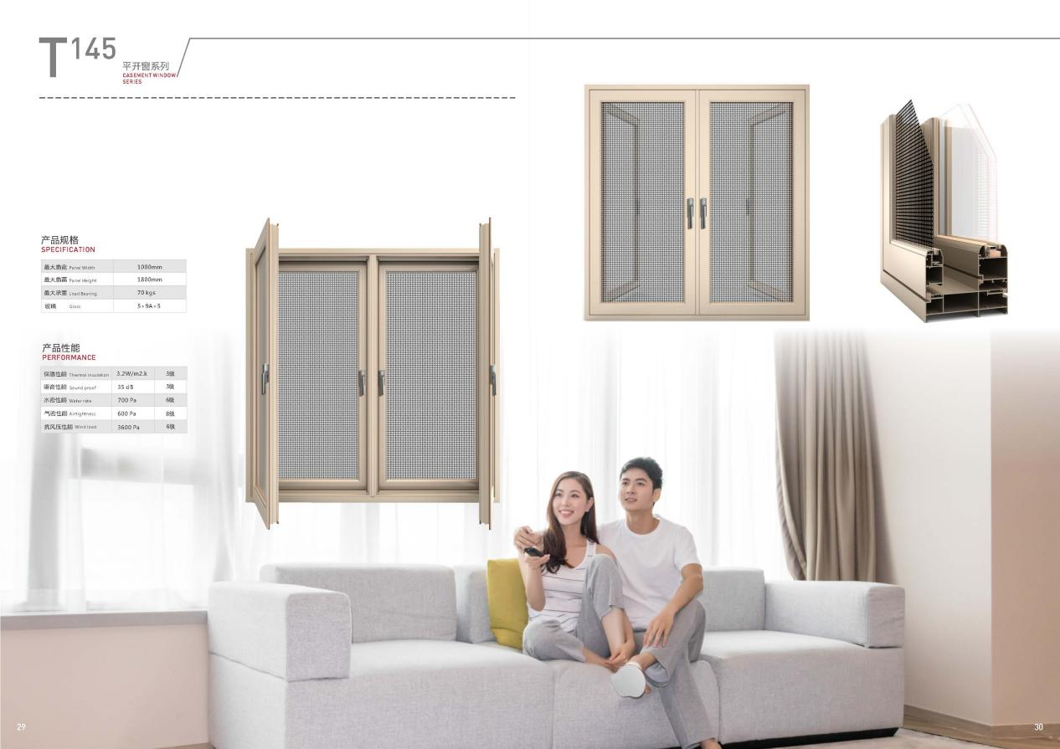

Model: T190

Product Name: Sliding Door

Material: [Aluminum](C:/Program%20Files%20(x86)/Youdao/Dict/8.9.6.0/resultui/html/index.html" \l "/javascript:;) frame,glass and hardware

Size: Customized

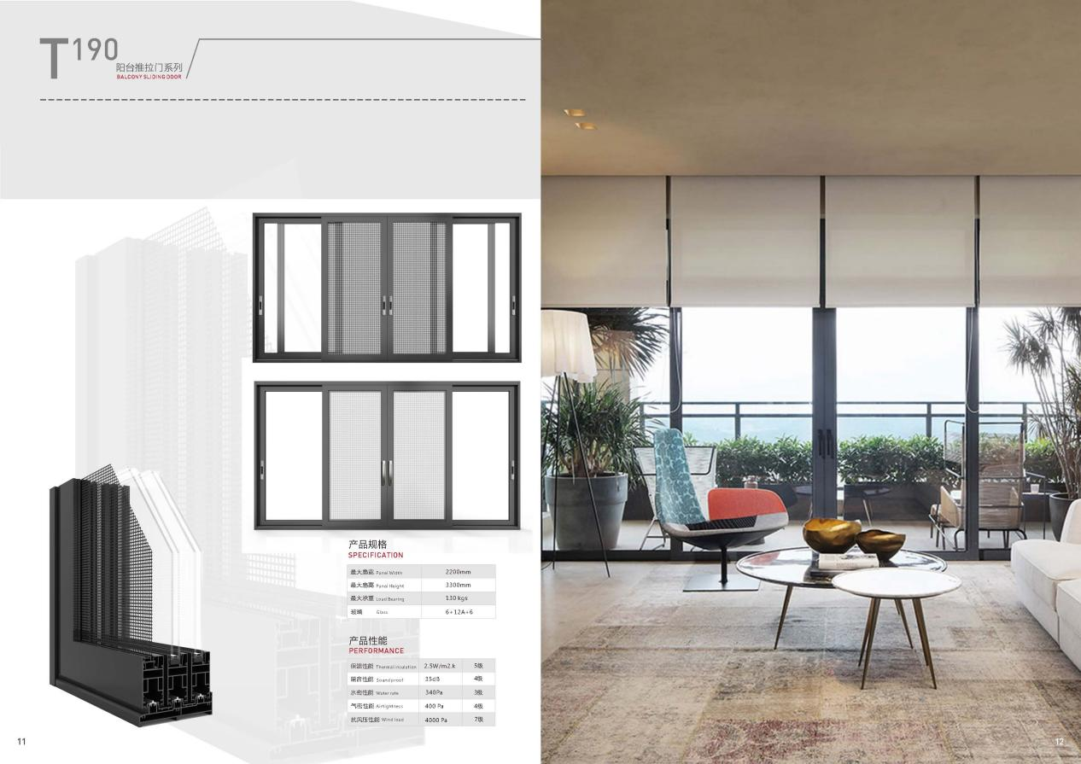

Model: T140

Product Name: Thermal Break Sliding Door

Material: [Aluminum](C:/Program%20Files%20(x86)/Youdao/Dict/8.9.6.0/resultui/html/index.html" \l "/javascript:;) frame,glass and hardware

Size: Customized

