Model: HLS2290

Product Name: Extendable Rectangle Outdoor Table

Material: Aluminium frame and teak top

Size: 2290/2950×1000×750mm

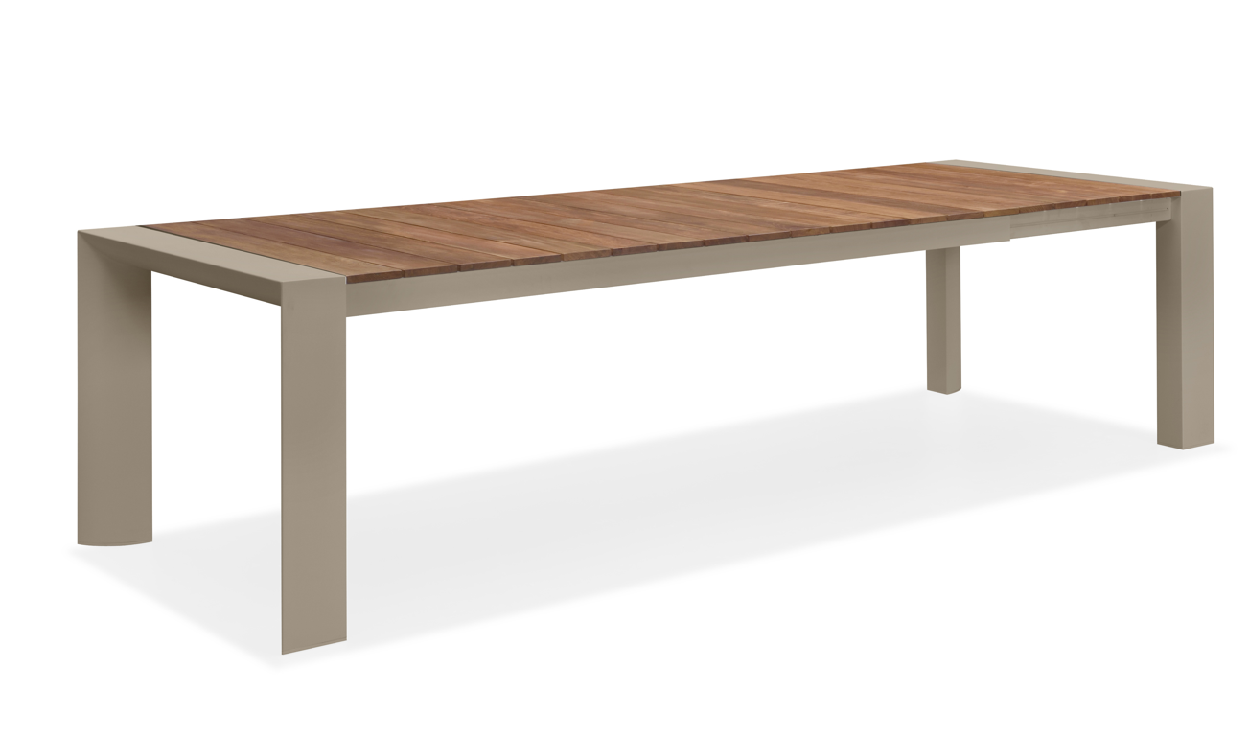

Model: HLS570

Product Name: Outdoor Chair

Material: Aluminium frame,mesh seat and teak arm rest

Size: 570×630×880 mm

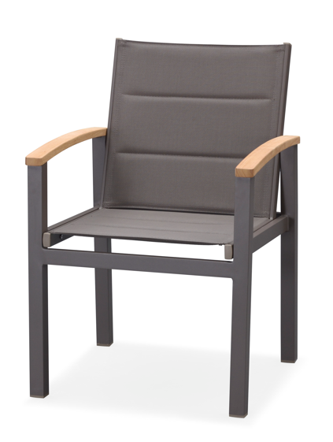

Model: HLS1940

Product Name: Sun lounger

Material: Aluminium frame and mesh seat

Size: 1940×700×960mm

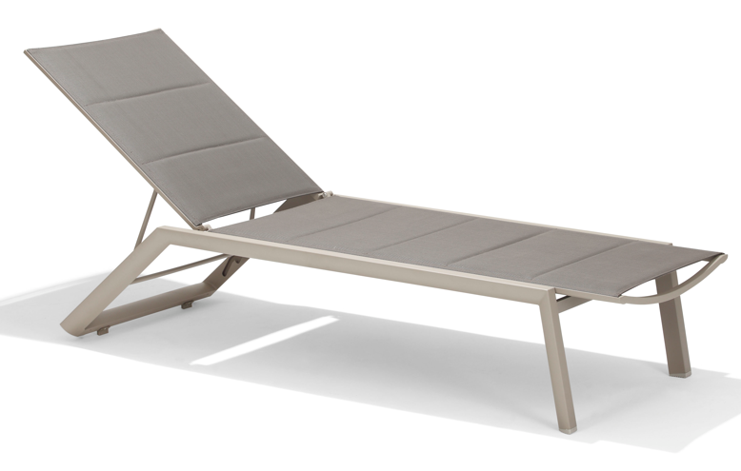

Model: HLS380

Product Name: Outdoor side table

Material: Aluminium and teak top

Size: 380×450×335mm

